Simple Key Interface Wiring Diagram:

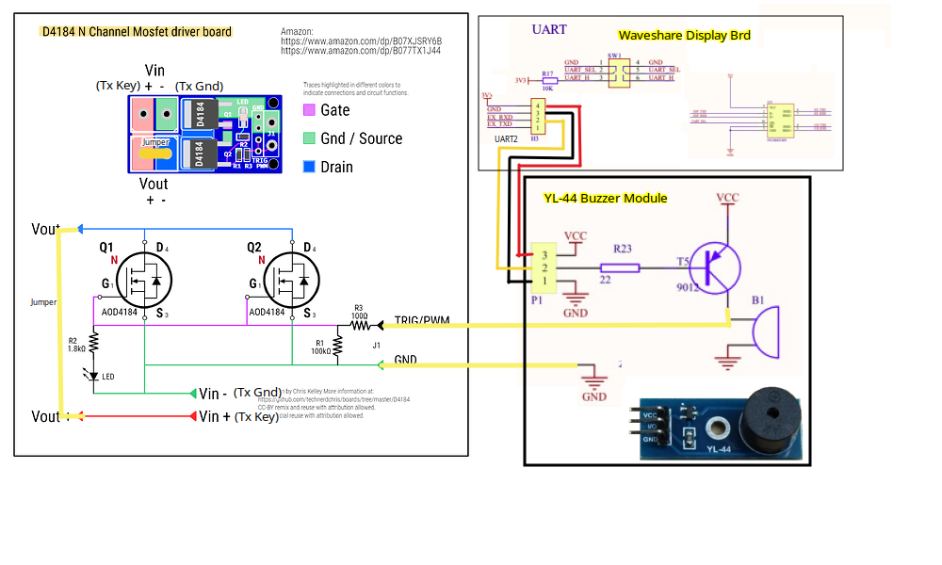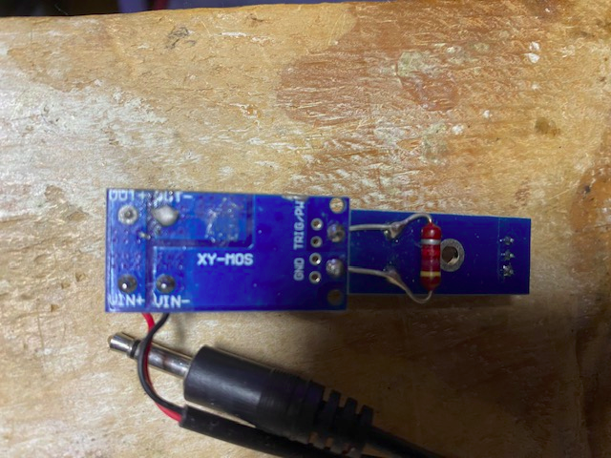Completed Key interface, using 4.7K resistor to connect buzzer and Mosfet driver: